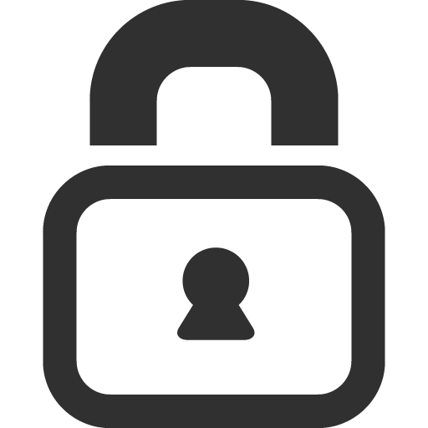

**Yes,That’s Me**

**Privacy Policy**

What information do we collect?

We **don't** collect any personal and activity data. This however **doesn't** apply to the Personality Types page where we strongly encourage you to read each website's privacy policy before submitting any personal data as we **aren't** to be held accountable for it.

# Do we share personal information?

We **don't** share personally identifiable information (such as name, address, email or phone) with other companies as we **don't** collect any. This however **doesn't** apply to the Personality Types page where we strongly encourage you to read each website's privacy policy before submitting any personal data as we **aren't** to be held accountable for it.

# Do ad companies collect data?

We currently **don't** provide ads.

# Do we use vendors or analytics providers?

We **don't** use vendors or analytics providers.

# How do we secure personal data?

We **don't** collect any personal data.

# What else should users know?

This privacy policy was last updated on 29/1/15. Our privacy policy may change from time to time. If we make any material changes to our policies, we will place a prominent notice in our application.